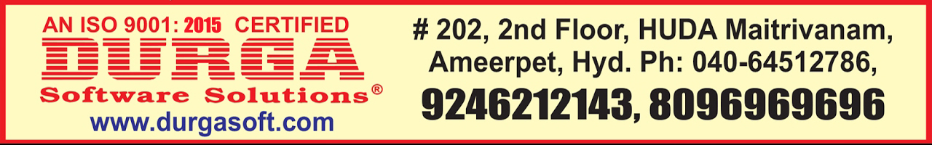

**--By Mr. Narayana**

**Core Django**

1. Introduction to Web Framework
   1. Introduction to Web framework
   2. Advantages of Web Framework
   3. Different types of Web Frameworks
   4. Features of Web Framework
2. Introduction to HTML
   1. What is HTML and markup-tags
   2. Working with headers and titles and paragraphs
   3. Applying spaces, comments and breaks to the HTML code
   4. Working with order and unorder lists
   5. Creating a table with HTML program and adding data to the tables
   6. Adding images to the HTML program.
   7. Creating text boxes and working with text boxes
   8. Working with Frames and Framesets
   9. Working with nested framesets
3. Introduction to Django
   1. History of Django
   2. Django Web Framework
   3. Advantages of Django Web Framework
   4. Features of Django Web Framework
   5. Difference between Django and Flask Web Frameworks
   6. Different types of Django products
4. Installations
   1. Installing Python and setting PATH for python
   2. Working with Python Package managers
   3. Difference between pip and easy_install
   4. Installing Django by using pip and easy_install
5. Creating virtual environment
   1. Purpose of virtual environment
   2. Installing virtualenv tool
   3. Using virtualenv tool to create virtual environment
   4. Creating multiple virtual environments
   5. Working with activate and deactivate files
6. Creating a project and installing Pycharm
   1. Creating project in virtual environment and at required place
   2. Working with project configuration directory
   3. Working with manage.py python script file
   4. Working with web development server
   5. __init__.py, settings.py, urls.py and wsgi.py files
   6. Installing and configuring Pycharm IDE
   7. Running web development server
   8. Creating a simple and default project
7. Creating an application and functions
8. Working with models
   1. Configuring to the database
   2. Installing apps and data access
   3. Activating models and checking the configurations
   4. Working with string representations
   5. Field types and field optional arguments
   6. Many to many, many to one and one to one
   7. Field name restrictions
   8. Migrations and __pycache__ files
   9. Working with compiled python files
   10. Multi table and multiple inheritance
   11. Creating and working with objects
   12. Working with queryset and filter methods
   13. Deleting and updating multiple objects
   14. Ordering and slicing the data
   15. Performing aggregations
   16. Manager and meta models
   17. Raw SQL queries and limiting query sets
   18. Abstract and proxy models
9. Working with Template System
   1. Introduction to template system
   2. Loading Template engine
   3. Defining a Template and Context constructors
   4. Rendering multiple Contexts to same Template class
   5. Working with Context variable lookup
   6. Handling invalid variable names in the Template
   7. Working with Django Template Tags and Filters
   8. %ifequal% and %ifnotequal%
   9. Working with views along with Templates
   10. Template inheritance

Advanced Django

1. Working with Django Admin site
   1. Creating Superuser and active users
   2. Creating staff status and super status users
   3. Working with edit forms and change list
   4. Django admin site working flow
   5. Django.autodiscover function
   6. Working with admin file
   7. Registering the models to load to admin site
   8. Creating classes in admin file
   9. Using admin.ModelAdmin class
   10. Creating and loading models into admin site
   11. Populating data to the models
   12. Working with inbuilt functionalities
   13. Working with List_display and list_filter attributes
   14. Working with filter_horizontal and filter_vertical attributes
   15. Raw_id_fields, search_fields and ordering attributes
   16. Changing admin site default settings
2. Working with forms
   1. What is a form and form tags
   2. Creating form class
   3. Working with required and widget optional fields
   4. Difference between django form and django model
   5. Validating the user input data
   6. Working with is_valid() and cleaned_data as_table attributes
   7. Working with POST and GET methods
   8. Working with send_mail and get_connection
   9. Working with HttpResponseRedirect and render and HttpResponse
   10. Creating a realtime application ContactUs form
   11. Working with user defined lables
   12. Setting the initial values for lables
3. Uploading files and images
   1. Working with ImageField and FileField types
   2. Creating a user defined directory to store files and images
   3. Working with upload_to attribute
   4. Uploading the files and images through models
   5. Working with MEDIA_ROOT and MEDIA_URLs
   6. Working with settings.DEBUG
   7. Downloading the files and images from django site
4. Working with Django Middleware
   1. Activating middleware
   2. Middleware execution order
   3. Process_request() and process_view()
   4. Process_exception(), process_template_responce() and process_responce()
   5. Cache,common and security middleware
   6. Conditional GET and local and message middleware
   7. GZip and site and authentication middleware
   8. Working with django.conf and django.views.static